Timeline Charts:

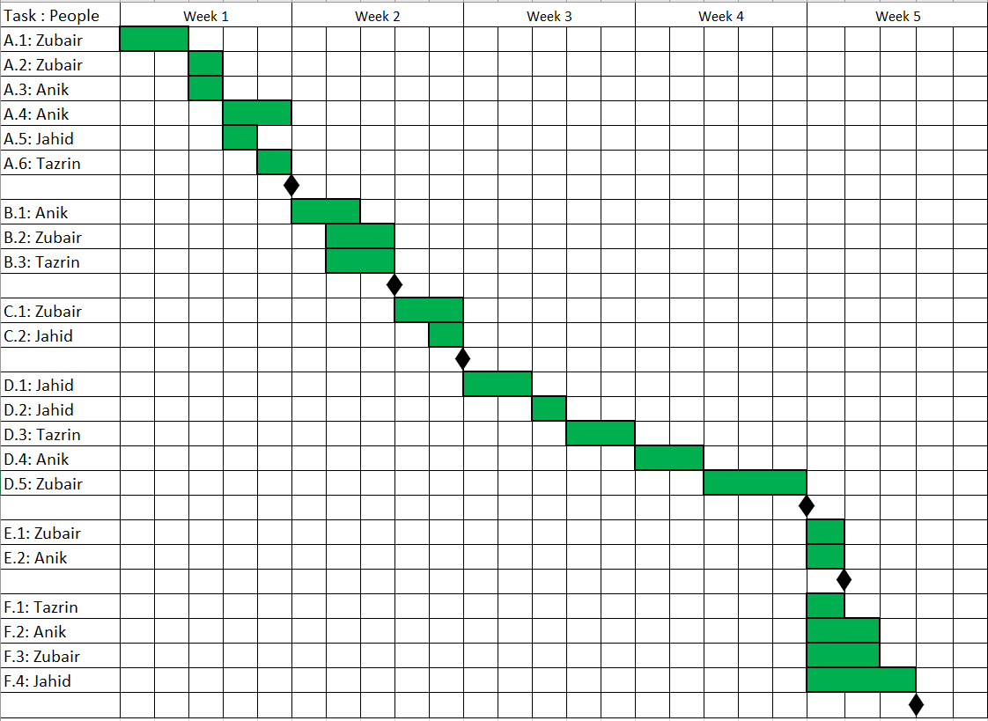

Activity Key:

|  |
| --- |
| **A : Requirements Analysis:** |
| 1. Identifying the requirements and purposes. |
| 1. Identifying the necessity and uses of the system. |
| 1. Creating a mind map. |
| 1. Identifying the simulation of establishing the requirements. |
| 1. Meeting with the customers and stakeholders. |
| 1. A complete building of model. |
| **B : Designing Part 1:** |
| 1. Use Case Diagram |
| 1. Mock Design |
| 1. Activity Diagram |
| **C : Designing Part 2:** |
| 1. Class Diagram |
| 1. ER Diagram |
| **D : Programming:** |
| 1. Identifying the appropriate algorithm. |
| 1. Programming Part 1 |
| 1. Programming Part 2 |
| 1. Programming Part 3 |
| 1. Programming Part 4 |
| **E: Management:** |
| 1. Representation of the Designing Parts on JIRA |
| 1. Storing the Programming Parts on GitHub |
| **F: Testing Phase and Debugging:** |
| 1. Unit Testing |
| 1. Integration Testing and Regression testing |
| 1. Security Testing |
| 1. Debugging the system |